**Itoc Cheat Sheet**

**Working knowledge of:**

* GitHub – at least know what it is:
  + GitHub is a Version Control System (VCS) for tracking changes in computer files.
* Python – be able to write a simple program:
  + Learned from the giraffe academy on youtube.
* System Administrator and Network troubleshooting on Linux, windows is a plus:
  + Continue working on Linux Youtube course.

**Core AWS knowledge:**

* You need basic skills:
* Watch the 10 minute tutorials on AWS (the compute and database tutorials at the least):
* Need to have completed the 3 associate exams within 3 months of joining Itoc:
* Solutions Architect Associate:
  + Completed all except the final exam and am constantly reviewing quizzes, exams and course material to better my understanding.
* Developer Associate:
  + Not started yet.
* SysOps Administrator Associate:
  + Not started yet.
* LinuxAcademy:
  + Not started yet.

**Know what they do at Itoc:**

* Look on their website:
  + They introduce clients to Cloud services and specifically AWS services.
  + They provide companies with the design, implementation and maintenance of cloud solutions.
* What is Managed Services?
  + Managed services is the practice of outsourcing on a proactive basis certain processes and functions intended to improve operations and cut expenses.
* Know what IaaS, PaaS and SaaS are:  
  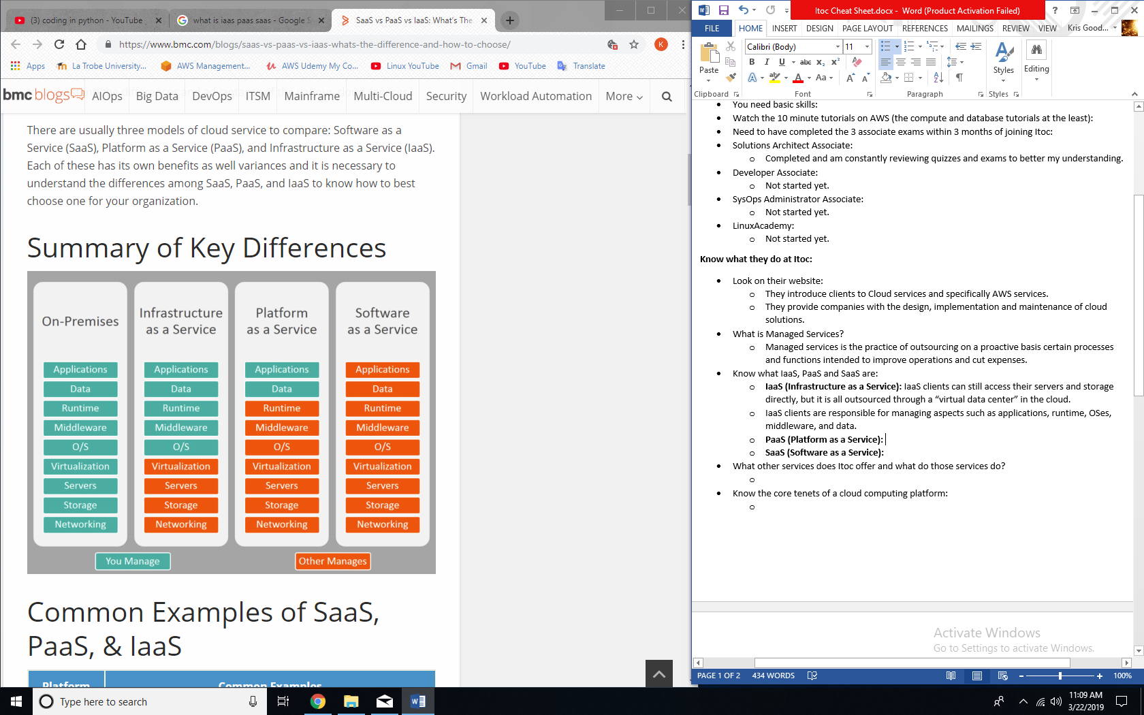
  + **IaaS (Infrastructure as a Service):** Cloud infrastructure services, known as Infrastructure as a Service (IaaS), are made of highly scalable and automated compute resources. IaaS is fully self-service for accessing and monitoring things like compute, networking, storage, and other services, and it allows businesses to purchase resources on-demand and as-needed instead of having to buy hardware outright.
  + IaaS clients can still access their servers and storage directly, but it is all outsourced through a “virtual data center” in the cloud.
  + IaaS clients are responsible for managing aspects such as applications, runtime, OSes, middleware, and data.
  + **Common examples:**
    - DigitalOcean, Linode, Rackspace, Amazon Web Services (AWS), Cisco Metapod, Microsoft Azure, Google Compute Engine (GCE)
  + **PaaS (Platform as a Service):** Cloud platform services, or Platform as a Service (PaaS), provide cloud components to certain software while being used mainly for applications. PaaS provides a framework for developers that they can build upon and use to create customized applications. All servers, storage, and networking can be managed by the enterprise or a third-party provider while the developers can maintain management of the applications.
  + **Common examples:**
    - AWS Elastic Beanstalk, Windows Azure, Heroku, Force.com, Google App Engine, Apache Stratos, OpenShift
  + **SaaS (Software as a Service):** Software as a Service, also known as cloud application services, represent the most commonly utilized option for businesses in the cloud market. SaaS utilizes the internet to deliver applications to its users, which are managed by a third-party vendor. A majority of SaaS applications are run directly through the web browser, and do not require any downloads or installations on the client side.
  + **Common examples:**
    - Google Apps, Dropbox, Salesforce, Cisco WebEx, Concur, GoToMeeting
* What other services does Itoc offer and what do those services do?
  + Financial services:
    - Itoc has extensive experience in the design and implementation of complex, large scale PCI-DSS (Payment Card Industry - Data Security Standard) AWS environments.
    - AWS services for financial services include: cloud enablement, cloud migration, intelligentOps, cloud architecture and consulting services, big data analytics, and machine learning.
  + Cloud enablement
    - Using thorough pragmatic analysis, design and implementation, Itoc implement cost effective, agile, secure starting points for AWS cloud services within client companies based on ITOC and AWS best practices.
  + Cloud migration:
    - Itoc provides scalable cloud migration services from one application to hundreds of applications.
  + Cloud transformation:
    - Itoc provides cloud transformation consultancy and engineering to help organizations define and adopt Agile and DevOps.
  + Cloud security:
    - Managing security essentials for companies such as access management, identity management, creating and managing secure infrastructure, auditing and monitoring for security breaches and threats, insurance in following compliance and governance of systems and services, active benchmarking to stay up to date with global security standards.
  + Cost optimization:
    - Bill analysis and triage.
    - Resource clean-up.
    - Tagging strategy.
    - Operating hours.
    - Standards and procedures.
    - Configuration enforcement.
    - Global cost optimization.
* Know the core tenets of a cloud computing platform:
  + Abstraction, automation and elasticity.
* Know the Grad and Intern programs at Itoc (to have an idea of how and what they teach to those with gaps.
  + All Itoc engineers must maintain all 5 AWS certifications.
  + The grad program is 12 months and the internship is 3 month rolling.
  + The programs get into a bit of everything from fixes and solutions with Itoc’s largest customers and their infrastructure, to designing new platforms that predict the future.
  + You learn all about the cloud and will be able to program infrastructure as code across a myriad of industries such as banking, government, retail and travel to name a few.
  + The added perks:
    - For the grad program:
      * A sign on bonus of $5k, half now and half when you’ve got the 5 AWS certs.
    - Generous investment in training in your first year (courses and mentorship.
    - Everyone gets a new MacBook/SurfacePro, multi monitors and iPhone or something equally shiny.
    - Uber travel allowance for “rainy days”.
    - Flexibility around hours and holidays.

**In summary:**

* Know what cloud elasticity is:
  + Cloud elasticity is the ability to grow or shrink infrastructure resources dynamically as needed to adapt to workload changes in an autonomic manner, maximizing the use of resources. This can result in savings in infrastructure costs overall.
* What are the common AWS components? – read the AWS page on Wikipedia, read the EC2, S3 and RDS pages on the AWS Website.
  + EC2, S3, RDS.
* Know Linux at a minimum standard to be effective. – use [this course](https://www.youtube.com/watch?v=bju_FdCo42w&list=PLtK75qxsQaMLZSo7KL-PmiRarU7hrpnwK).
  + I have watched all of the videos a couple times.
* After a few months any new engineer at Itoc should be able to build an entire multi-tier standard web application stack in AWS that is multi AZ and highly available. Any simple web app will do that demonstrates these principles. At this point you are becoming a Cloud Guru.